



**B.Sc. in Interactive Digital Art and Design**

**Academic Year 2023 / 2024**

**Project Diary & Notebook**

Name: _ Anastasia Kravale _____________

Student ID: _ C00271786 __________________

Supervisor: _ Roxanne Burchartz ____________

Project Title: _ ’The Big Pitcher’ Dingle Animation Festival

1. **This is an important Document – Do not lose it!**
2. **Schedule of Dates and Project Deliverables**
3. 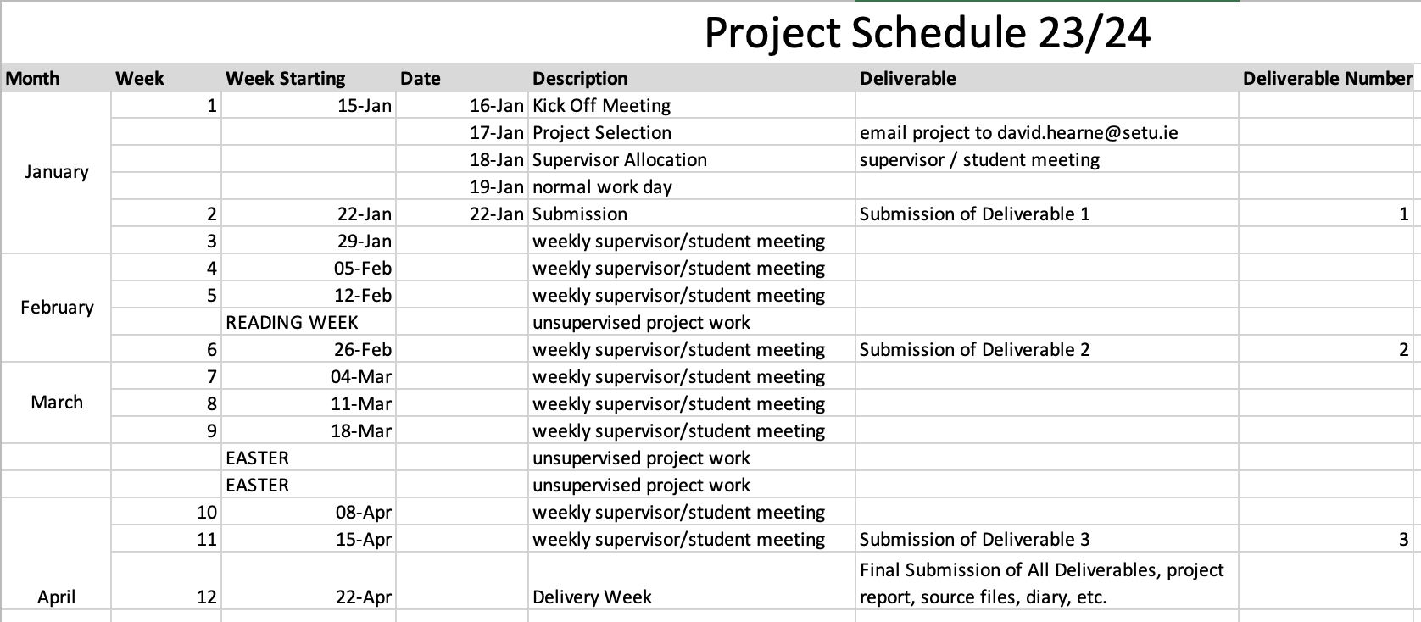
4. **IDAD Project Documents**
5. **Proposal: 1 page**
6. Specification of the type of web presence to be modelled. Background of the proposed Business environment / application.
7. Proposal should include a description of the entity intended to model as well as a reason (or reasons) for how the entity would benefit from having a web presence.
8. **Planning & Research document: (5 marks)**
9. Project plan & timeline
10. Platform choice, software stack choice, description existing system, similar existing sites,
11. Proposed outline site map (basic)
12. **Project Requirements & Specification: (10 marks)**
13. Overview of Business
14. Project Objectives, User roles,
15. Functional requirements of each user:
16. Features & functional specification for each user: List features & purpose of features
17. **Design & Storyboard: (10 marks)**
18. Content plan and flow, design specifications, Storyboard
19. **Progress Presentation: (10 marks)**
20. Brief Description of Project, work done so far, work you still have to do, Technology Options/Discussion, Potential Issues/Challenges
21. **Project Final Report: (15 marks)**
22. Description of Submitted Project, Description of Conformance to Specification and Design,
23. Description of Learning, Scrum experience; Full Review of Project
24. **Technical document: Admin & Setup Guide (10 marks)**
25. Detailed instructions on how to **install**, **set-up**, **configure** and **use** the system.
26. **Project Management: Stand Up Meetings and Diary (10 marks)**
27. Evidence that the project process was executed effectively and effeciently through all the stages through to final production.
28. **Full rubric will be available in a separate document.**

# PROJECT DOCUMENTATION STANDARDS

All documents submitted as part of the project are to be word processed and submitted on-line. Upload links will be provided at the relevant deliverable dates.

The format of each document must conform to this specification:

* Title Page: including your project title, name, login-id, supervisor's name, and date of submission.
* Table of Contents.
* Introduction to the report
* Page numbering (in a footer) is required on all pages *except* the title page.
* References and a bibliography are required for all material sourced from elsewhere (including printed works and material from the Internet). The format of references is to conform to the published standards for the *Department of Computing*.

Be sure to spell-check your documents *before* submission.

________________________________________________________________________

**Work submitted for assessment which does not include this declaration will not be assessed.**

# DECLARATION

*I declare that all material in this submission e.g. thesis/essay/project/assignment is entirely my/our own work except where duly acknowledged.

*I have cited the sources of all quotations, paraphrases, summaries of information, tables, diagrams or other material; including software and other electronic media in which intellectual property rights may reside.

*I have provided a complete bibliography of all works and sources used in the preparation of this submission.

*I understand that failure to comply with the Institute’s regulations governing plagiarism constitutes a serious offence.

Student Name: (Printed) _ ANASTASIA KRAVALE _______________________

Student Number: _ C00271786 _________________________________

Signature: _Anastasia___________________________________

Date: _22 April 2024_________________________________

**Please note:**

The Institute regulations on plagiarism are set out in Section 13.3 Examination and Assessment Regulations published each year in the Student Handbook.

**Week 1 Beginning**: 15 / 01 / 24

**Description of Work Completed**:

Project description was given. I decided to work on an animation for the Dingle Animation Festival.

‘The Big Pitcher’. Completed a research document with due dates of deliverables, what I need to do,

software I will use, etc. Started writing down ideas for an animation.

________________________________________________________________________________

**Notes (and things to remember)**:

Continue working on coming up with a good animation idea.

________________________________________________________________________________

**Signed (and dated)**: 19 / 01 / 24.

_Anastasia_____________________________ _______________________________________

**Student** **Supervisor**

**Week 2 Beginning**: 22 / 01 / 24.

**Description of Work Completed**:

Came up with an idea, completed a write up word document and some character sketches.

Decided I wasn’t happy with the animation idea because it felt like it was for kids.

Started thinking of new animation ideas for another series.

________________________________________________________________________________

**Notes (and things to remember)**:

Make it for older audience, like teens and young adults.

________________________________________________________________________________

**Signed (and dated)**: 26 / 01 / 24.

_Anastasia_____________________________ _______________________________________

**Student** **Supervisor**

**Week 3 Beginning**: 29 / 01 / 24.

**Description of Work Completed**:

After meeting with supervisor, got feedback and advice.

Started writing down cartoons I like and seeing what I can take from them.

What makes a good animated series.

Ended up with an idea for a series and completed a word document about it.

Submitted it to the supervisor.

________________________________________________________________________________

**Notes (and things to remember)**:

Add more details about each character and more backstory and the overarching narrative.

________________________________________________________________________________

**Signed (and dated)**: 02 / 02 / 24.

_Anastasia_____________________________ _______________________________________

**Student** **Supervisor**

**Week 4 Beginning**: 05 / 02 / 24.

**Description of Work Completed**:

Received feedback on the document.

Again, decided I dislike my idea and tried coming up with a short story instead.

Tried coming up with one but it was too like ‘The Ugly Duckling’, and it wasn’t original.

Began writing down themes I want to include and managed to come up with a new short story.

Completed a PowerPoint presentation on my project progress, presented it, and got feedback.

Written a synopsis, tagline, title, longline, about my short story.

Drew images of protagonist and background for the Pitcher.

Submitted everything on the Dingle website through ‘The Big Pitcher’.

________________________________________________________________________________

**Notes (and things to remember)**:

Draw images of; the title, other characters in the animation, other backgrounds (outside, shop, park).

Work on a set document! Include: demographic, duration, animation technique (2D), software,

art style, any dialogue (mention that there is none), music.

________________________________________________________________________________

**Signed (and dated)**: 09 / 02 / 24.

_Anastasia_____________________________ _______________________________________

**Student** **Supervisor**

**Week 5 Beginning**: 12/ 02 / 24.

**Description of Work Completed**:

Drew more images for my animatic.

Done some background sketches and character sketches.

Drew Nanas house and completed the title screen.

Chosen students were announced

My animation was not selected.

Continued working on the visuals of the animatic.

________________________________________________________________________________

**Notes (and things to remember)**:

Finish drawing assets and backgrounds, and characters.

Decide on the software to use for animatic.

________________________________________________________________________________

**Signed (and dated)**: 16/ 02 / 24.

_Anastasia______________________________ _______________________________________

**Student** **Supervisor**

**Week 6 Beginning**: 26 / 02 / 24.

**Description of Work Completed**:

Continued with my drawings on backgrounds, characters and assets.

Submitted deliverable 2 for the project.

Looked at sounds that could go with the animatic.

________________________________________________________________________________

**Notes (and things to remember)**:

Find a song that would be nice during the animatic.

________________________________________________________________________________

**Signed (and dated)**: 02 / 03 / 24.

__Anastasia____________________________ _______________________________________

**Student** **Supervisor**

**Week 7 Beginning**: 04 / 03 / 24

**Description of Work Completed**:

Doing my animatic.

Using the backgrounds and characters for now.

Getting the timing of each frame.

________________________________________________________________________________

**Notes (and things to remember)**:

Add assets like flour, apples, etc.

Still need to find a song for the background.

________________________________________________________________________________

**Signed (and dated)**: 08 / 03 / 24

__Anastasia__________________________ _______________________________________

**Student** **Supervisor**

**Week 8 Beginning**: 11 / 03 / 24

**Description of Work Completed**:

Still working on the animatic.

Added more detail to my background.

Coloured in most pictures to make them look better.

Added few assets to the animatic.

________________________________________________________________________________

**Notes (and things to remember)**:

________________________________________________________________________________

**Signed (and dated)**: 15 / 03 / 24

__Anastasia___________________________ _______________________________________

**Student** **Supervisor**

**Week 9 Beginning**: 18 / 03 / 24

**Description of Work Completed**:

Getting near the end of the animatic.

Most frames are done, still need to be timed more.

So far all the assets are used.

________________________________________________________________________________

**Notes (and things to remember)**:

During easter finish all the backgrounds and final characters.

________________________________________________________________________________

**Signed (and dated)**: 22/03/24

__Anastasia_________________________ _______________________________________

**Student Supervisor**

**Week 10 Beginning**: 08 / 04 / 24

**Description of Work Completed**:

Drew face expressions for Nana to see her emotions.

Added Nanas expressions to the animatic.

________________________________________________________________________________

**Notes (and things to remember)**:

Find sound for animatic?

Time the frames

________________________________________________________________________________

**Signed (and dated)**: 12/04/24

__Anastasia___________________________ _______________________________________

**Student Supervisor**

**Week 11 Beginning**: 15 / 04 / 24

**Description of Work Completed**:

Completing the animatic.

Timing the frames better.

Added all the assets, backgrounds.

Drew better side characters as they weren't the same style as rest of animatic.

Started writing final report, half way done.

________________________________________________________________________________

**Notes (and things to remember)**:

Submit everything on Monday.

Complete final report.

________________________________________________________________________________

**Signed (and dated)**: 26/04/24

__Anastasia_____________________________ _______________________________________

**Student Supervisor**

**Week 12 Beginning**: 22 / 04 / 24

**Description of Work Completed**:

Completed Final report.

Uploaded everything on Github and blackboard.

________________________________________________________________________________

**Signed (and dated)**: 22/04/24

__Anastasia__________________________ _______________________________________

**Student Supervisor**